TOPIC 5: TRIGONOMETRIC RATIO 2
Having studied the concept of three sided 2-D shapes called Triangles; as well as the properties exhibited with respect to its sides and the angles between them, we now move further towards applying derived Trigonometric ratios in advanced concepts and problems.
Objectives:
At the end of this session, the students will be able to:
- Explain, clearly, the concept of ELEVATIONS AND DEPRESSIONS
- Solve problems involving the application of Trig. Ratios to angles of elevation and depressions.
- Apply trigonometric ratios to solve problems on Bearing and Distances.
ELEVATIONS AND DEPRESSIONS
Elevation simply refers to a raised position of an entity, be it a person, a view, etc. A higher level or placement is what the concept of Elevation represents.
Thus, the Angle of Elevation is the angle formed when we view such raised entities from the natural line of sight, which is the horizontal.
Similarly, Depression refers to a reduced position, or a lower level or placement of a body compared to our viewing point. It therefore follows that the Angle of Depression is the angle formed when we view such entities in lower, downward positions from the natural line of sight.
Diagrammatically,
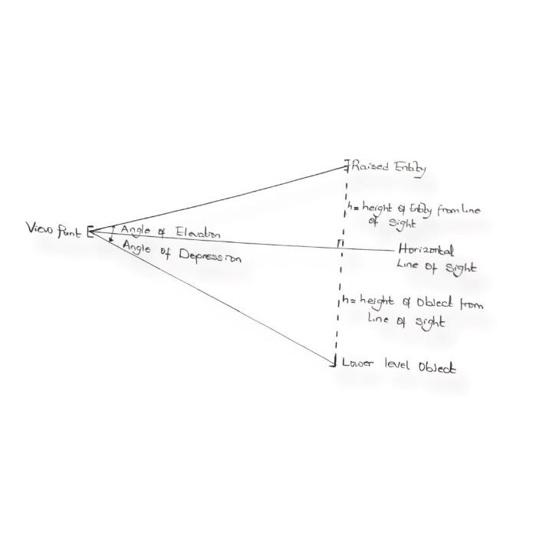

TRIVIA
The Angle of Elevation or Depression formed is always acute. Thus, we can simply resolve it as an angle within the right-angled triangle formed from the horizontal line of sight and the object or entity either upward or downward.
EXAMPLES
- A science building is 50m high and the angle of elevation at the top of the building is 63$°$when seen from a point on level ground. Find the distance between the point and the foot of the building.
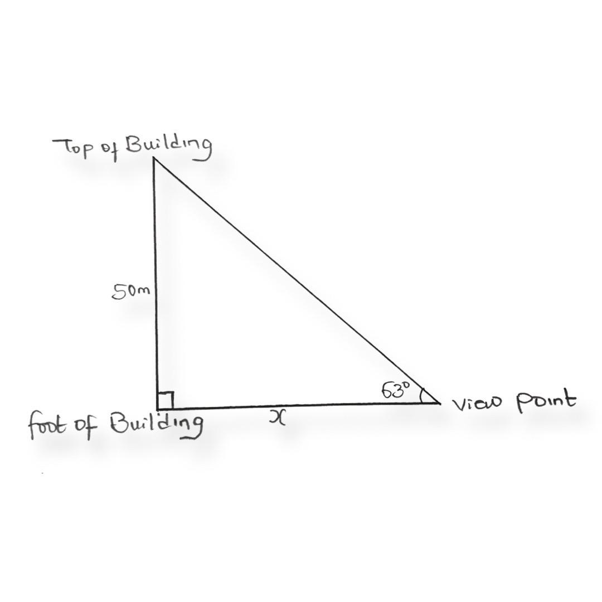
By SOHCAHTOA

$$tantan 63=\frac{50}{X}$$
x = $\frac{50}{tantan 63 }$
X= 25.48m

Hence, the distance between the view point and the foot of the building is 25.48m
- A man who is 6ft tall stands on horizontal ground 30m from a tree. The angle of elevation of the top of the tree is 35$°$. What is the height of the tree.
6 Ft = 1.829meters
Since, 1m ≈ 3.28 feet.

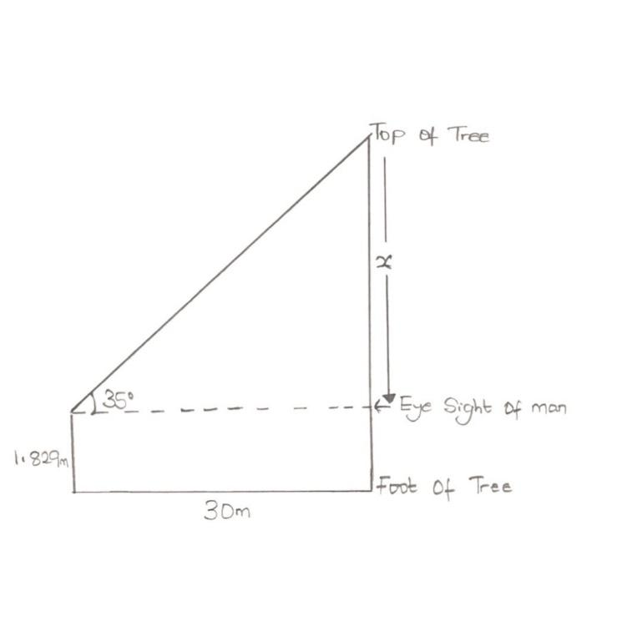

Tan 35 = $\frac{x}{30}$
x = 30 Tan 35
x = 21.01m
Thus, Height of tree = x + height of man
= 21.01 + 1.829
= 22.839m ≈ 22.84m
- A lady who is 1.5m tall stands at the top of skyscraper, and faintly views a point below 450m away from the foot of the sky scraper at an angle of 30$°$. What is the height of the skyscraper?

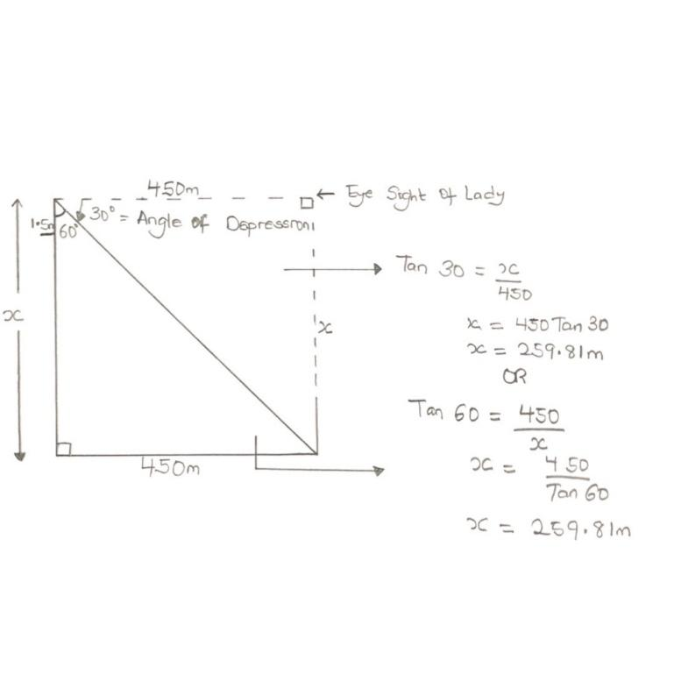

Thus,
Height of skyscraper= x – height of lady
= 259.81 – 1.5m
= 258. 31m
BEARING AND DISTANCES
Bearing refers to the direction or position of something, be it object or place, relative to a fixed point. It is measured in degrees and the clock-wisely from the NORTH position. Bearings are either measured in terms of poles, or in terms of their complete degree readings.
Since the distance between each pole is 90$°$, the pole readings are $≤90°.$
The complete degree readings lie between 0$° and 360°,$ which is the sum of all four poles, in clockwise direction.
EXAMPLE
N50$°E is equivalent to 050°$
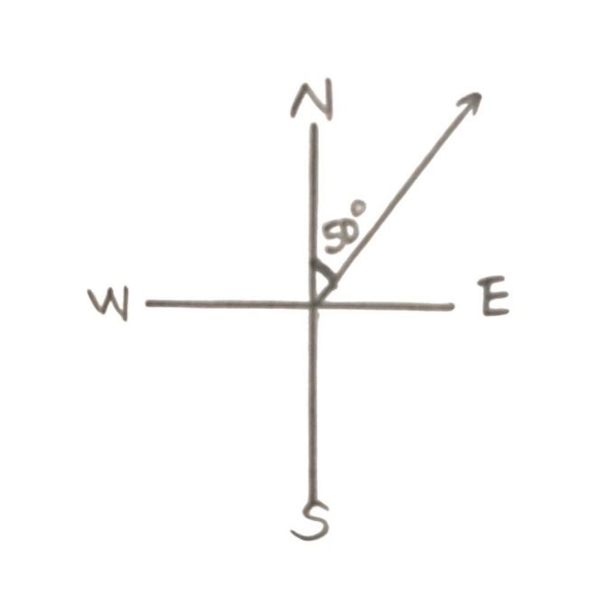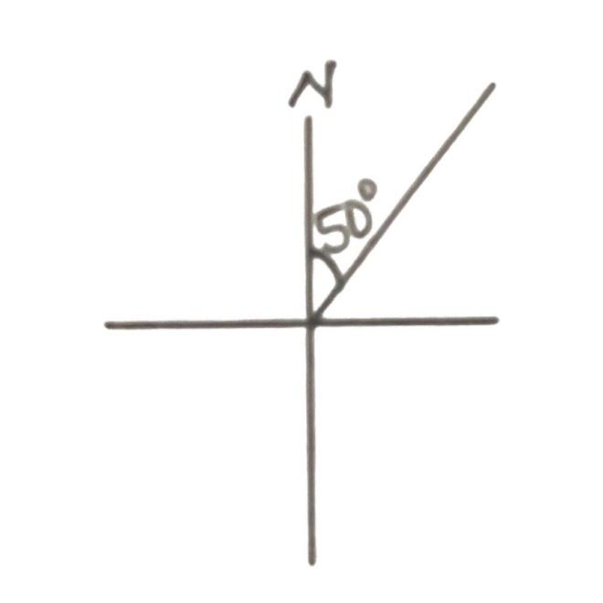

S 45$°W is equivalent to 225° in the 3rd quadrant$
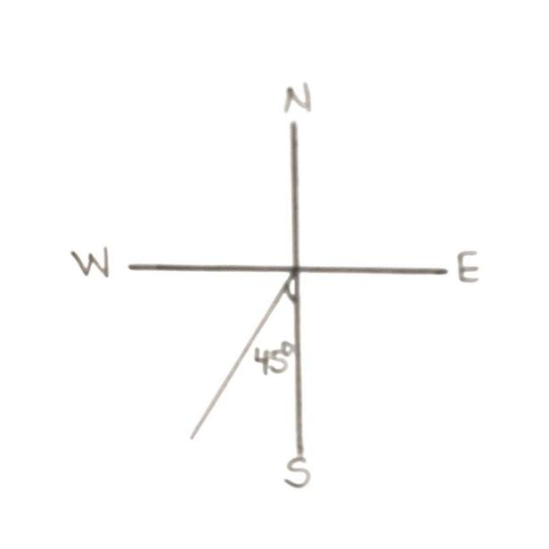 | 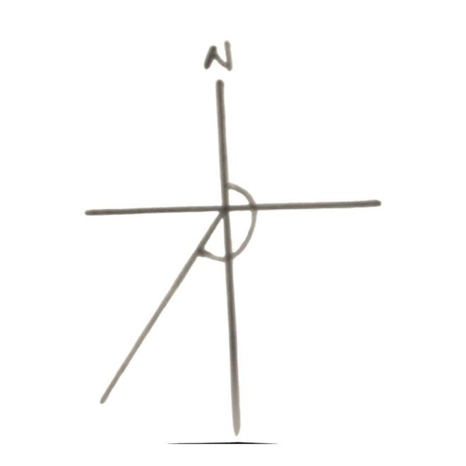

Distance refers to the measure of travel from one bearing point to the other bearing point, to its relative fixed point.
TRIVIA:
Early levels of bearing and distance resolve simply into triangles. In fact, for even more complex bearing combinations, it is possible to group them into triples, to form a triangle.
EXAMPLE:
- A is on a bearing of 065$°$from B means that we plot on the point B, the angle 065$°.$ A would then be our destination. x is then said to be the distance between A and B.
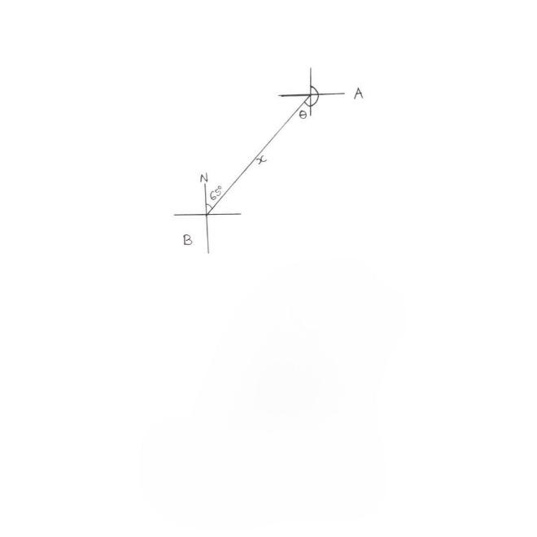

Notice that $θ=65° and the bearing of B from A= θ+180°.$
In fact, $θ and 65°$ are called Opposite Angles.
TRIVIA:
- A from B means B is the start point and A is the end point.
- From A to B means A is the start point and B is the End point.
- B is “Due North” of A means that A is the start point and the bearing is 000$°$.
- A is “Due East” of B means that B is the start point and the bearing is 090$°$.
- Due South and Due West mean bearing of 180$°$ and 270$°$ respectively.

- A boat sails 6km from a dock A on a bearing of N30$°$E to a point B thereafter sails due south towards a landing port that is 3km due East of A. Find the distance between B and the landing port.
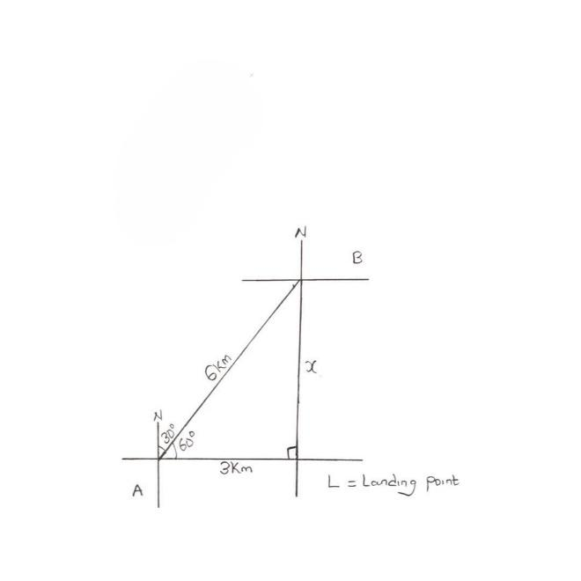

By SOHCAHTOA OR by Pythagoras’ Theorem,
Sin 60$°$ = $\frac{x}{6}$ $6^{2}= x^{2}+ 3^{2}$
x = 6 Sin 60$°$ $x^{2}= 6^{2}- 3^{2}$
x = 5.196km $x^{2}=36-9=27$
x = 5.196km
Hence, the distance between B and the landing port is 5.196km.

QUESTIONS:
- Tom is trying to determine the angle to aim his sprinkler nozzle to water the top of a 10ft bush in his compound. Assuming the water takes a straight path and the sprinkler is on the ground 4ft from the tree, at what angle of inclination should she set it.
- Kaitlyn is swimming in the ocean and notices a coral reef below her. The angle of depression is 35$°$ and the depth of the ocean at that point is 350ft. How far away is she from the reef?
- The distance from a boat to a lighthouse is 100feet and the lighthouse is 120ft tall. What is the angle depression from the top of the lighthouse to the boat?
- A ship is 4km due East and then 3km due North. Find the distance from his original position.
- A village is 10km on a bearing 050$°$ from a point 0. How far is the village North of 0?

Solution to Questions
- Tan $θ=\frac{10}{4}$
$θ=(\frac{5}{2} )$
$$θ=68.2°$$
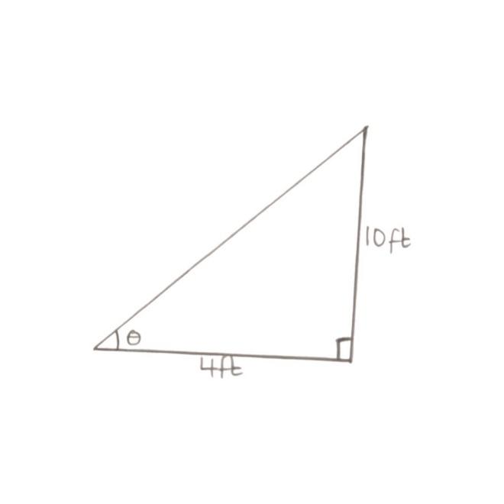

- x is the distance of Kate from the reef
Sin 35$°= \frac{350}{x}$
x = $\frac{350}{sinsin 35 }$
x = 610.21ft
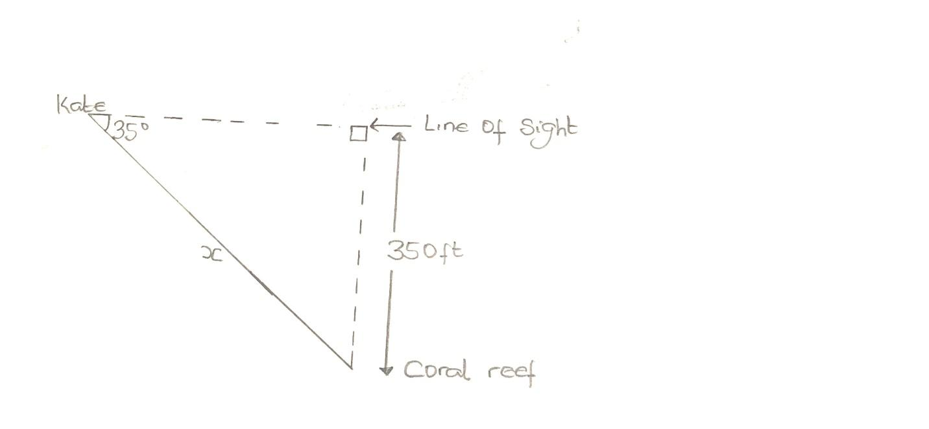

- Tan$θ=\frac{100}{120}$
$θ=(\frac{5}{6} )$
$$θ=39.81°$$
this $μ=90°- θ=90°-39.81°$
$μ=50.19°$
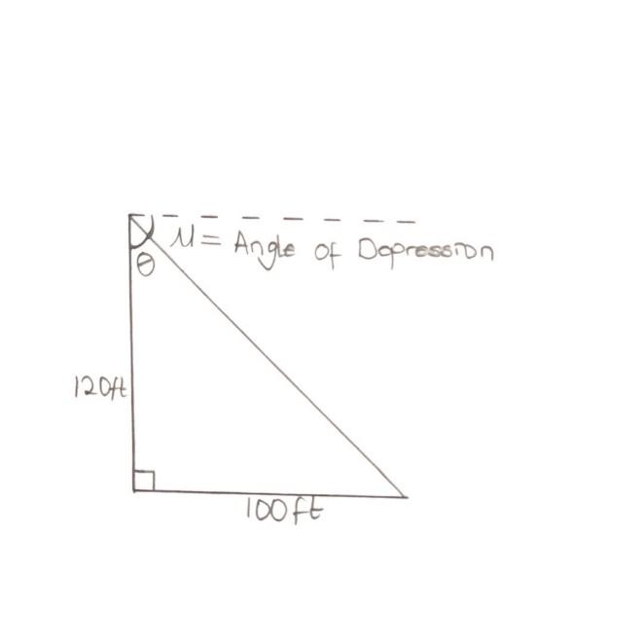

- By Pythagoras theorem,
$$x^{2}= 4^{2}+ 3^{2}$$
$x^{2}= 16+9$ =25
x = 5km
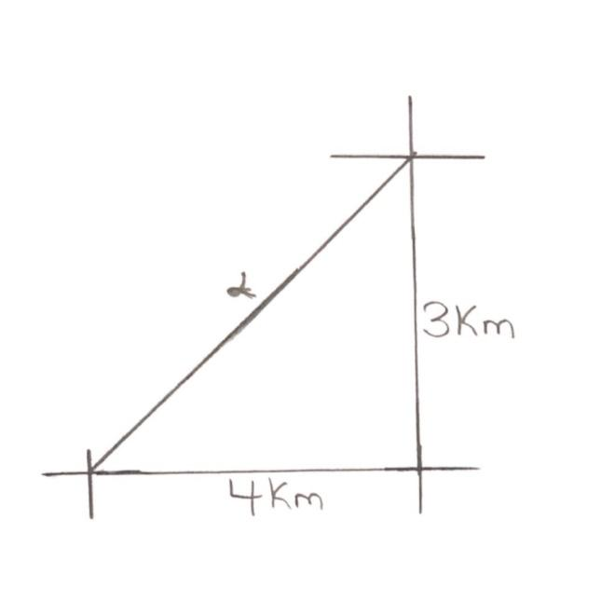

- By SOHCAHTOA,
$$coscos 50°=\frac{x}{10}$$
x = 10 $cos50°$
x = 6.43km
